

**Fundamental of programming Assignment 1**

**Name: Muhammad Yahya Chand**

**Section: ME-15 B**

**CMS ID: 456727**

#include<iostream>

using namespace std;

int main(){

int x;

cout<<"Enter the number: ";

cin>>x;

cout<<"Factors of "<<x<<" is: "<<endl;

for(int i=1;i<=x;i++){

if(x%i==0){

cout<<i<<endl;

}

else{

continue;

}

}

return 0;

}

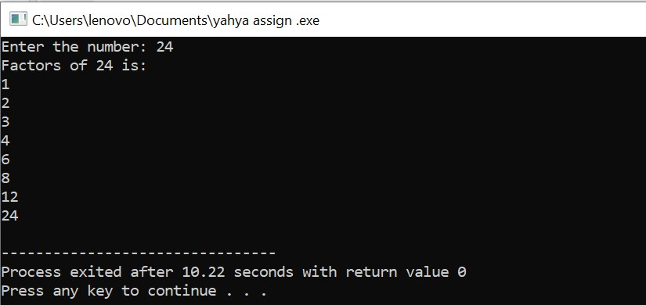

Task#2:

#include <iostream>

int main() {

int x = 5;

int y = 10;

if (x == 5)

if (y == 10)

std::cout << "x is 5 and y is 10" << std::endl;

else

std::cout << "x is not 5 " << std::endl;

return 0;

}

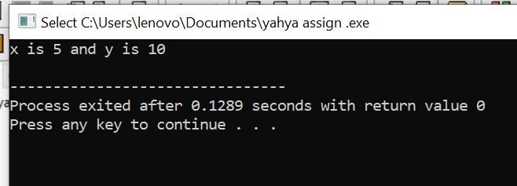

Task#3:

#include<iostream>

using namespace std;

int main(){

int a;

cout<<"Enter a number: ";

cin>>a;

if(a>10 && a<=20){

cout<<"print1";

}

else{

cout<<"print0";

}

return 0;}

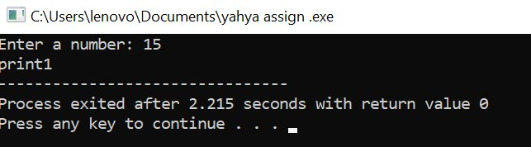

Task#4:

#include<iostream>

using namespace std;

int main(){

int num=0,a, b=1,factors=0;

cout<<"Enter a number: ";

cin>>num;

a=num;

if(num<=1){

cout<<"Enter a number greater than or equal to 2";

}

else{

while(num>=2){

factors=0;

b=1;

while(b<=a){

if(num%b==0){

factors++;

}

b++;

}

if(factors==2){

break;

}

num--;

}

cout<<"the largest prime number less than or equal to "<<a<<": "<<num;

}

return 0;

}

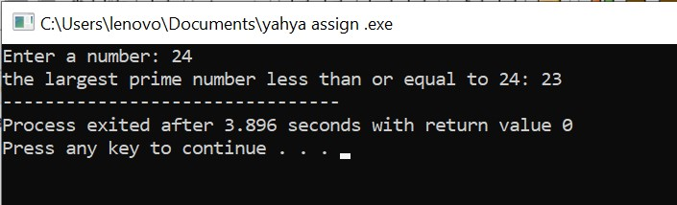

Task#5:

#include<iostream>

using namespace std;

int main(){

string sti1, sti2, rev;

rev = " ";

cout<<"Enter String1: ";

cin>>sti1;

cout<<"Enter String2: ";

cin>>sti2;

if (sti1 == sti2) {

for (int i = 0; i < sti1.length(); i++) {

rev = sti1[i] + rev;

}

cout<<"Strings are equal.The changed string is: ";

cout<<rev;

}

else {

cout<<"Strings are not equal";

}

return 0;}

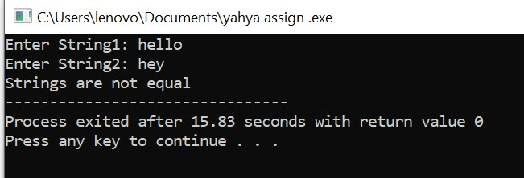

Task#6:

#include<iostream>

using namespace std;

int main(){

int divisor, quotient;

int remainder, dividend;

cout<<"Enter a divisor: ";

cin>>divisor;

cout<<"Enter a dividend larger than divisor: ";

cin>>dividend;

if (dividend < divisor) {

cout<<"dividend shall be greater than divisor.";

return 1;

}

remainder = dividend;

for (int i = 1; i <= dividend; i++) {

remainder -= divisor;

if (remainder < divisor) {

quotient = i;

break;

}

}

cout<<"Ans = "<<quotient;

return 0;}

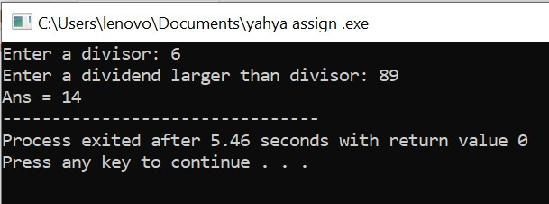

**Task#7:**

#include<iostream>

using namespace std;

int main(){

string sti, result;

bool find;

result = "";

cout<<"Enter the String: ";

cin>>sti;

for (int i = 0; i < sti.length(); i++) {

find = false;

for (int j = 0; j < result.length(); j++) {

if ( sti[i] == result[j] ) {

find = true;

}

}

if (find == false) {

result += sti[i];

}

}

cout<<"resultant string= "<<result;

return 0;

}

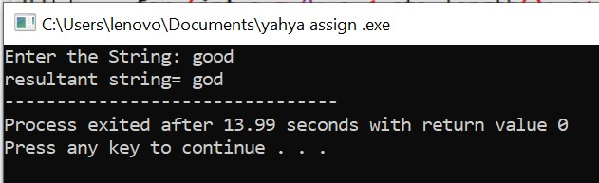

**Task#8:**

#include<iostream>

using namespace std;

int main(){

int arr1[8], arr2[5] = {1,2,3,4,5};

cout<<"the array is: {";

for (int i = 0; i<5; i++) {

cout<<arr2[i];

if (i==4)

continue;

cout<<", ";

}

cout<<"}"<<endl;

for (int i = 0; i<5; i++) {

arr1[i] = arr2[i];

}

cout<<"Enter the 3 integers that you want to add to the array: "<<endl;

for (int i = 5; i<8; i++)

cin>>arr1[i];

cout<<"the new elements of the array are:"<<endl;

for (int i = 0; i<8; i++) {

cout<<arr1[i]<<" ";

}

return 0;}

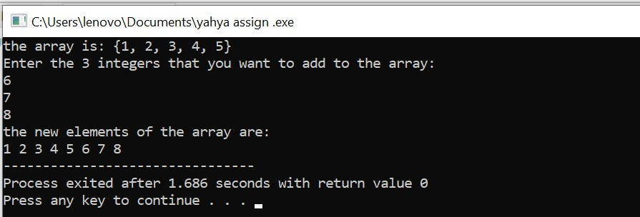

**Task#9:**

#include<iostream>

using namespace std;

int main(){

int a, b, c;

int sum,n, arr[10];

cout<<"Enter 10 integers:"<<endl;

for (int i = 0; i<10; i++) {

cin>>arr[i];

}

bool found = false;

cout<<"Enter integer n: ";

cin>>n;

cout<<"the Triplets are: ";

for (int i = 0; i<10; i++) {

for (int j = 0; j<10; j++) {

if (i == j){

continue;}

for (int k = 0; k<10; k++) {

if (k == i || k == j)

{continue;

}

sum = arr[i] + arr[j] + arr[k];

if (sum == n) {

cout<<" ("<<arr[i]<<", "<<arr[j]<<", "<<arr[k]<<")";

found = true;

}

}

}

}

if (found == false) {

cout<<"No Triplet";

}

return 0;}

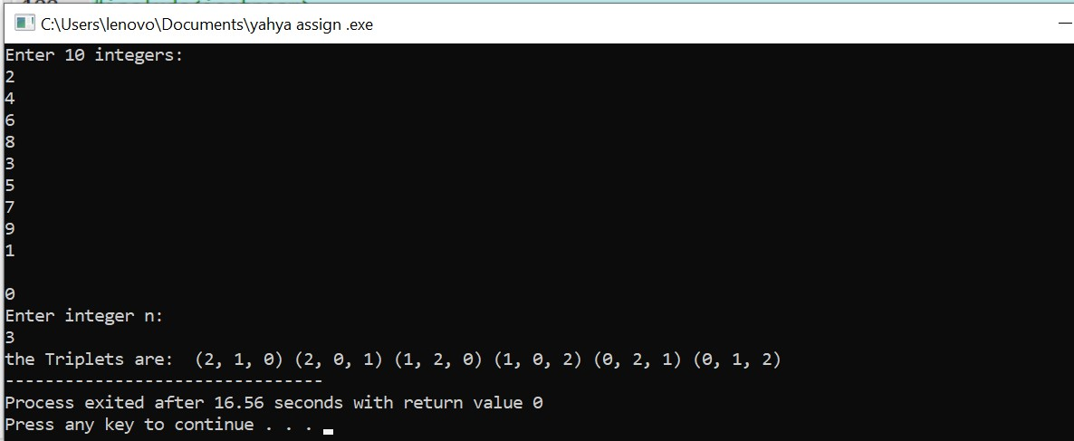

**Task#10:**

#include<iostream>

using namespace std;

int main(){

int temp, a = 6, arr1[a];

cout<<"Enter "<<a<<" integers: "<<endl;

for (int i = 0; i<a; i++) {

cin>>arr1[i];

}

for (int j = 0; j<(a-1); j++) {

for (int i = 0; i<(a-1); i++) {

if (arr1[i]>arr1[i+1]) {

temp = arr1[i];

arr1[i] = arr1[i+1];

arr1[i+1] = temp;

}

}

}

cout<<"Array= {";

for (int i = 0; i<a; i++) {

cout<<arr1[i];

if (i == a-1){

continue;

}

cout<<",";

}

cout<<"}";

return 0;

}

